|  |  |
| --- | --- |
| EGC_Black | Student Name \_\_\_\_\_\_\_\_\_\_\_\_\_\_\_\_\_\_\_\_\_\_\_    **Eastern Goldfields College**  Mathematics Applications U3&4 2017  Test 6 1– Calculator Free Section |
| **Working Time: 20 minutes** | **Total Marks: 21 marks** |

**Question 1 [3 marks]**

The arc lengths between the five vertices A, B, C, D and E of a network are shown in the table below. Determine the length of the minimum spanning tree for this network.

|  |  |  |  |  |  |
| --- | --- | --- | --- | --- | --- |
|  | A | B | C | D | E |
| A | 0 | 13 | 15 | 14 | 12 |
| B | 13 | 0 | 12 | 14 | 11 |
| C | 15 | 12 | 0 | 13 | 13 |
| D | 14 | 14 | 13 | 0 | 14 |
| E | 12 | 11 | 13 | 14 | 0 |

**Question 2 [2 marks]**

Show the minimum spanning tree on the following network.

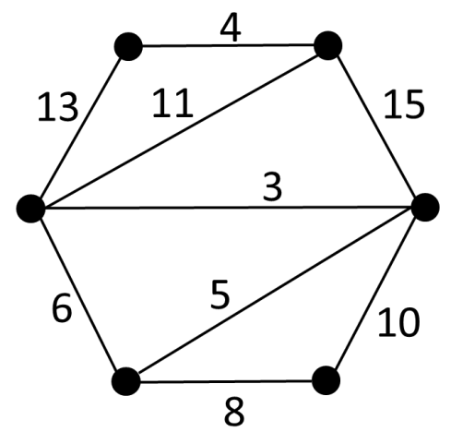

**Question 3 [7 marks: 2, 2, 1, 2]**

Consider the following project network for baking a cake. All times are in minutes.



I 5

1. State the minimum amount of time required to back a cake?
2. State the critical path?
3. Task I is icing making. What is the maximum amount of time icing making can be delayed before there is a change to the critical path?
4. If Julie begins the project at 1:42 pm and uses all the float time allowed for making the icing and finishes this activity, she will finish at exactly 3:05 pm. Explain how this has been calculated.

**Question 4 [9 marks: 1, 4, 2, 2]**

Joni, Ian, Dylan and Joshua are teachers in a school. The school has a Maths class, an English class, a Geography class and a Science class that need a teacher. Each teacher can be allocated one class only.

Joni can teach English or Geography. Ian can teach Maths or Science. Dylan can teach English or Geography. Joshua can teach Geography or Science.

1. What type of graph would be best to display this information?
2. Construct a graph of the information above and use it to decide on the assignment of each teacher to a subject.
3. Explain why Joshua must take the Science class.
4. Is there another possible assignment solution of teacher to subject? If so, write the alternative allocation, if not, explain why.

|  |  |
| --- | --- |
| EGC_Black | Student Name \_\_\_\_\_\_\_\_\_\_\_\_\_\_\_\_\_\_\_\_\_\_\_    **Eastern Goldfields College**  Mathematics Applications U3&4 2017  Test 5 1– Calculator Assumed Section |
| **Working Time: 35 minutes** | **Total Marks: 32 marks** |

**Question 1 [3 marks]**

The tasks involved in a project, their immediate predecessors and duration, are shown below.

|  |  |  |  |  |  |  |  |  |  |  |
| --- | --- | --- | --- | --- | --- | --- | --- | --- | --- | --- |
| Task | A | B | C | D | E | F | G | H | I | J |
| Immediate predecessor | - | A | A | A | C | B | D | G | F, E, H | I |
| Duration (days) | 14 | 3 | 42 | 100 | 14 | 3 | 1 | 1 | 2 | 1 |

Add the information from the table to the project network below.

[Note: The diagram below is not drawn to scale]

**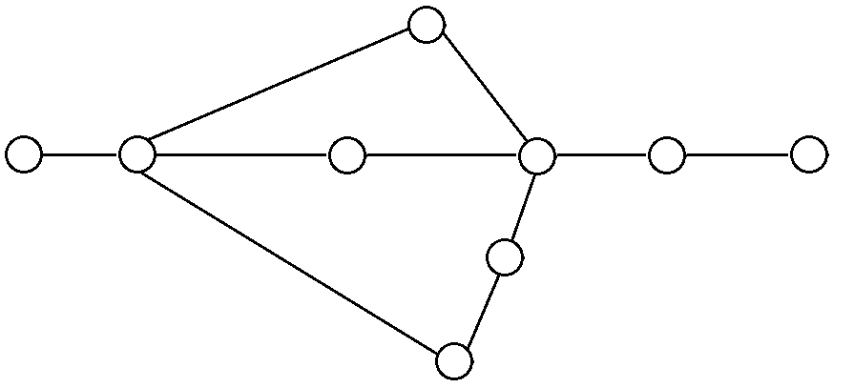**

**Question 2 [7 marks: 3, 2, 2]**

The network below shows the existing pipes in a garden reticulation scheme. The letters A to O represent the watering stations and the network must be connected to the main as shown. The owner wishes to replace the old rusty pipes with new pipes so that the water may flow more efficiently.

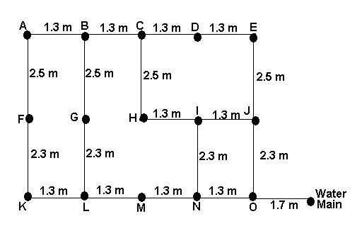

a) What is the minimum amount of pipe that needs to be replaced so that each of the stations ***(A to O)*** is connected by new pipe to the water main. *(ie. Find the minimum spanning tree of the network)*.

b) The current layout has obvious inefficiencies. Using the measurements from above design a completely new layout that would allow the least amount of pipe to be used in the network. Show this on the network below.

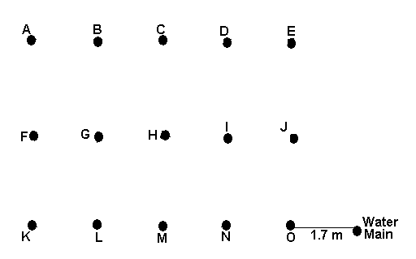

c) Given that the new pipe cost $25 per metre to install, how much money would have been saved using your solution to part (b) instead of part (a).

**Question 3 [10 marks: 5, 2, 3]**

The network below shows the available paths to transport raw product from mine M to port P. The number on each arc is the maximum weight of raw product that can be moved along it, in hundreds of tonnes per hour.

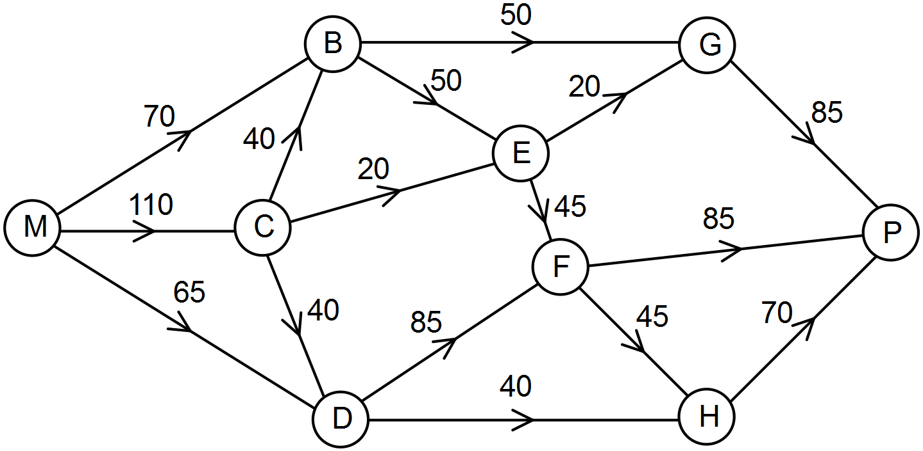

1. Determine the maximum weight of raw product that can be transported in one hour from the mine M to the port P. Show systematic working.
2. Show maximum flow equals minimum cut



1. The mine transport manager has funds to increase the capacity of arc CB or arc CD by up to 3 000 tonnes per hour. Determine which, if either, would be the best to choose and calculate the new maximum weight of raw product that can be transported in one hour from the mine M to the port P. Justify your answer.

**Question 4 [12 marks: 1, 3, 8]**

Four people needing a kidney transplant and four willing donors are ranked according to the potential for a successful transplant. 0 being not a successful match and 100 being a perfect match. The following table shows a summary of the results.

|  |  |  |  |
| --- | --- | --- | --- |
|  | **Donor 1** | **Donor 2** | **Donor 3** |
| **Recipient A** | 26 | 29 | 30 |
| **Recipient B** | 58 | 55 | 56 |
| **Recipient C** | 75 | 78 | 69 |

1. If a computer randomly allocated recipients to donors and the allocation is shown below, calculate the potential success rate out of 300.



1. Is there a better allocation of recipients to donors in order to maximise the chance of success? Justify your answer.

1. If another recipient and another donor are included in the process show how the Hungarian algorithm can be used to identify the maximum chances of success by matching the recipients to the donors. (There are blank tables on next page to assist you.)

|  |  |  |  |  |
| --- | --- | --- | --- | --- |
|  | **Donor 1** | **Donor 2** | **Donor 3** | **Donor 4** |
| **Recipient A** | 26 | 29 | 30 | 25 |
| **Recipient B** | 58 | 55 | 56 | 60 |
| **Recipient C** | 75 | 70 | 69 | 70 |
| **Recipient D** | 66 | 68 | 68 | 65 |

|  |  |  |  |  |
| --- | --- | --- | --- | --- |
|  | **Donor 1** | **Donor 2** | **Donor 3** | **Donor 4** |
| **Recipient A** |  |  |  |  |
| **Recipient B** |  |  |  |  |
| **Recipient C** |  |  |  |  |
| **Recipient D** |  |  |  |  |

|  |  |  |  |  |
| --- | --- | --- | --- | --- |
|  | **Donor 1** | **Donor 2** | **Donor 3** | **Donor 4** |
| **Recipient A** |  |  |  |  |
| **Recipient B** |  |  |  |  |
| **Recipient C** |  |  |  |  |
| **Recipient D** |  |  |  |  |

|  |  |  |  |  |
| --- | --- | --- | --- | --- |
|  | **Donor 1** | **Donor 2** | **Donor 3** | **Donor 4** |
| **Recipient A** |  |  |  |  |
| **Recipient B** |  |  |  |  |
| **Recipient C** |  |  |  |  |
| **Recipient D** |  |  |  |  |

**END OF TEST**